## Phoenix Contact FL switch SFNT series

### Specification

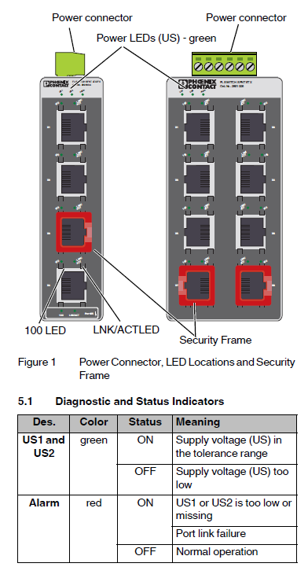

Figure 2‑37: Drawing and diagnostics

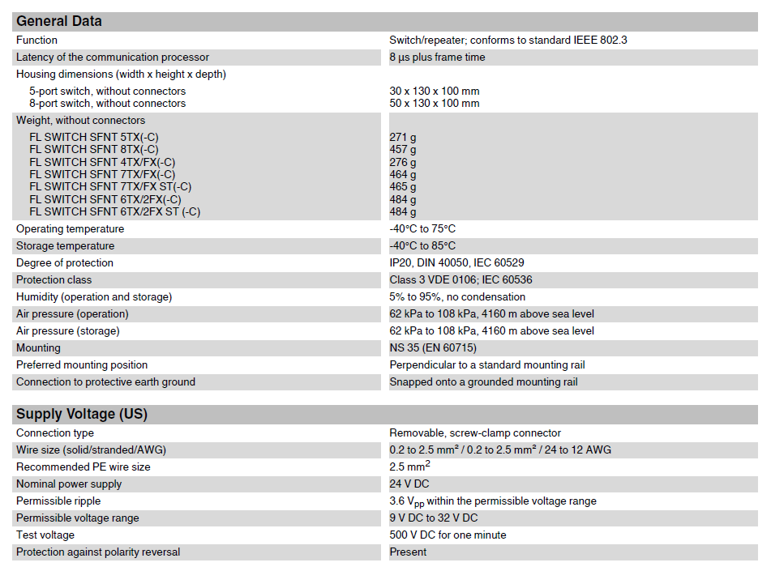

Figure 2‑38: General data

### Installation

Install requirements are set in the specifications. Lan cables to be used must be at least Cat5E.